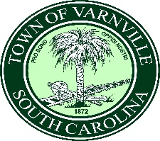APPLICATIONS FOR MISS VARNVILLE

Applications are now available for Miss Varnville 2023 at the Varnville Town Hall.

Qualifications are as follows: Never married, between the ages of 17 and 25, must live within the town limits of Varnville, and be willing to make appearances for the town as needed.

All applications and pictures must be in by May 2,2023 at 5:00 P. M. at the Varnville Town Hall, 95 East Palmetto Avenue, P O Box 308, Varnville, SC 29944

